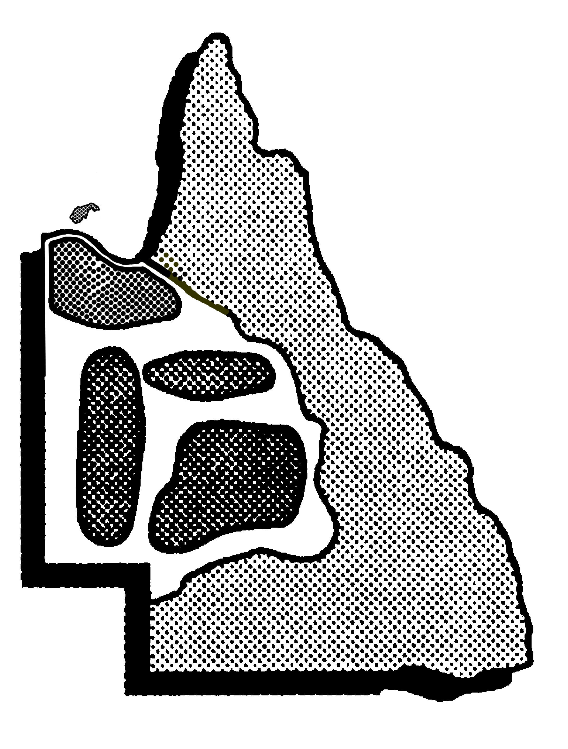
NORTH WEST UNIFORM SIZING CHART
Item | Sizes Available
Ankle Socks | M  2-7 |  | L  7-11 |  | XL  11-14
Football Socks (League/Soccer) | M  2-7 |  | L  7-11 |  | XL  11-14
Softball Socks (Striker) | XS  9-2 |  | Jun  2-8 |  | Sen  6-10
Basketball Tube Socks (Deleted) | S  2-7 |  | M  7-11 |  | L  11-14
Bucket Hat | 55cm |  | 57cm |  | 59cm
Cap | One Size
Neoprene Sunvisor | One Size
Cricket Cap | One Size
Swimming Cap | One Size
Slouch Hat | 53cm | 55cm
Maroon Broad Brim | 57cm | 59cm
Dress Polo Shirts | 8/5XS  80cm | 10/4XS  84cm |  | 12/3XS  88cm |  | 2XS  92cm |  |  | XS  94cm |  | S  100cm |  | M  106cm |  | L  112cm |  | XL  118cm |  | 2XL  124cm |  | 3XL  130cm |  | 4XL  136cm
Polo Shirts (Clearance Stock) |  |  |  |  |  |  |  |  |  |  |  |  | L  110cm |  | XL  115cm |  | 2XL  120cm |  | 3XL 125cm
Singlets (V & Round Neck) | 10Y  80cm | 12Y  85cm |  | 14Y  90cm |  | 16Y  95cm |  |  | S  100cm |  | M  105cm |  | L  110cm |  | XL  115cm |  | 2XL  120cm |  | 3XL  125cm |  | 4XL  130cm
Walkout T-Shirt (Clearance Stock) |  |  |  |  |  | M  105cm |  |  | L  110cm |  | XL  115cm |  | 2XL  120cm |  | 3XL  125cm |  | 4XL  130cm
Long Sleeve Surf Shirt | 10/3XS  84cm | 12/2XS  88cm |  | XS  94cm |  | S  100cm |  |  | M  106cm |  | L  112cm |  | XL  118cm |  | 2XL  124cm |  | 3XL  130cm |  | 4XL  136cm
Tracksuit Jacket (chest) | 10  70cm | 12  78cm |  | XS  85cm |  | S  90cm |  |  | M  95cm |  | L  100cm |  | XL  105cm |  | 2XL  110cm |  | 3XL  115cm |  | 4XL  120cm |  | 5XL  125cm |  | 6XL  130cm
Tracksuit Pants (waist) | 10  63cm | 12  66cm |  | XS  71cm |  | S  76cm |  |  | M  82cm |  | L  86cm |  | XL  91cm |  | 2XL  96cm |  | 3XL  101 |  | 4XL  106 |  | 5XL  111 |  | 6XL
Touch Singlets (Girls - chest) | 10  68cm | 12  75 |  | XS  82 |  | S  89 |  |  | M  95 |  | L  102
Touch Bike Pants (Girls – waist) | 10/W4  58 | 12/W6  61 |  | XS/W8  65 |  | S/W10  70 |  |  | M/W12  75 |  | L/W14  80
Netball Dress (chest) | C10  75cm | C12 80cm |  | C14  85cm |  | 8  90cm |  |  | 10  95cm |  | 12  100cm |  | 14  105cm |  | 16  110cm |  | 18  115cm |  | 20  120cm
Netball Skirt | 8 | 10 |  | 12 |  | 14 |  |  | 16 |  | 18 |  | 20 |  | 22 |  | 24
Playing Shirt (Soccer,Softball, Tennis) (chest) | 10  70 | 12  78 |  | XS  85 |  | S  90 |  |  | M  95 |  | L  100 |  | XL  105 |  | 2XL  110 |  | 3XL  115 |  | 4XL  120
Playing Shirt (Touch) New 09 (chest) | 10  70 | 12  78 |  | XS  85 |  | S  90 |  |  | M  95 |  | L  100 |  | 105 |  | 110 |  | 115 |  | 120
Rugby League Jersey (chest) | 12  78cm | XS  85cm |  | S  90cm |  | M  95cm |  |  | L  100cm |  | XL  105cm |  | 2XL  110cm
Dress Shorts  (waist) | 8  62cm | 10  70cm |  | 12  78cm |  | XS  85cm |  |  | S  90cm |  | M  95cm |  | L  100cm |  | XL  105cm |  | 2XL  110cm |  | 3XL  115cm |  | 4XL  120cm |  | 5XL  125cm
Playing Shorts (League, Touch, Athletics) (waist) | 10  64cm | 12  68cm |  | XS  72cm |  | S/32  77cm |  |  | M/34  82cm |  | L/36  87cm |  | XL/38  92cm |  | 2XL/40  97cm |  | 3XL/42  102cm |  | 4XL/44  107cm |  | 5XL/46  110cm |  | 6XL/48  115cm
Girls Softball Knickerbokkers | 8 | 10 |  | 12 |  | 14 |  |  | S |  | M |  | L |  | 20 |  | 22
Bike Pants | G8 | G10 |  | G12 |  | XS |  |  | S |  | A10 |  | A12 |  | A14 |  | A16
Bummies/ Briefs | 8Y | 10Y |  | 12Y |  | 14Y |  |  | L12 |  | L14 |  | L16 |  | L14-16
Polar Fleece Jumper | 10  84cm | 12  88cm |  | XS  94cm |  | S  100cm |  |  | M  106cm |  | L  112cm |  | XL  118cm
Hoodie | 3XS | 2Xs |  | XS |  | S |  |  | M |  | L |  | XL |  | 2XL |  | 3XL
Team Official Polo Shirts | 2XS  92cm | XS  94cm |  | S  100cm |  | M  106cm |  |  | L  112cm |  | XL  118cm |  | 2XL  124cm |  | 3XL  130cm |  | 4XL  136cm
Supporters Polo Shirts | 2XS  92cm | XS  94cm |  | S  100cm |  | M  106cm |  |  | L  112cm |  | XL  118cm |  | 2XL  124cm |  | 3XL  130cm |  | 4XL  136cm
Back Sack | One Size
Large Sports Bag | One Size
Back Pack | One Size

