Quick Reference Guide

Reducing Levy Quantities from the Cart
Occasionally, a Parent will add more levies than intended to their cart and they are unable to remove the extra item/s.
The following example looks at assisting a Parent with removing an extra Regional Trial Levy accidentally added to their cart.
Step |  | Details
 | Once the Regional Trial Levies have been added to the cart, the Student information required pop up box will appear prompting the Parent to enter the Student Names and Schools for each levy added to the cart.  The Parent must complete all fields to satisfy the system requirements, allowing them to progress to the section where they can remove the additional levies. | The first entry will be the actual student details.  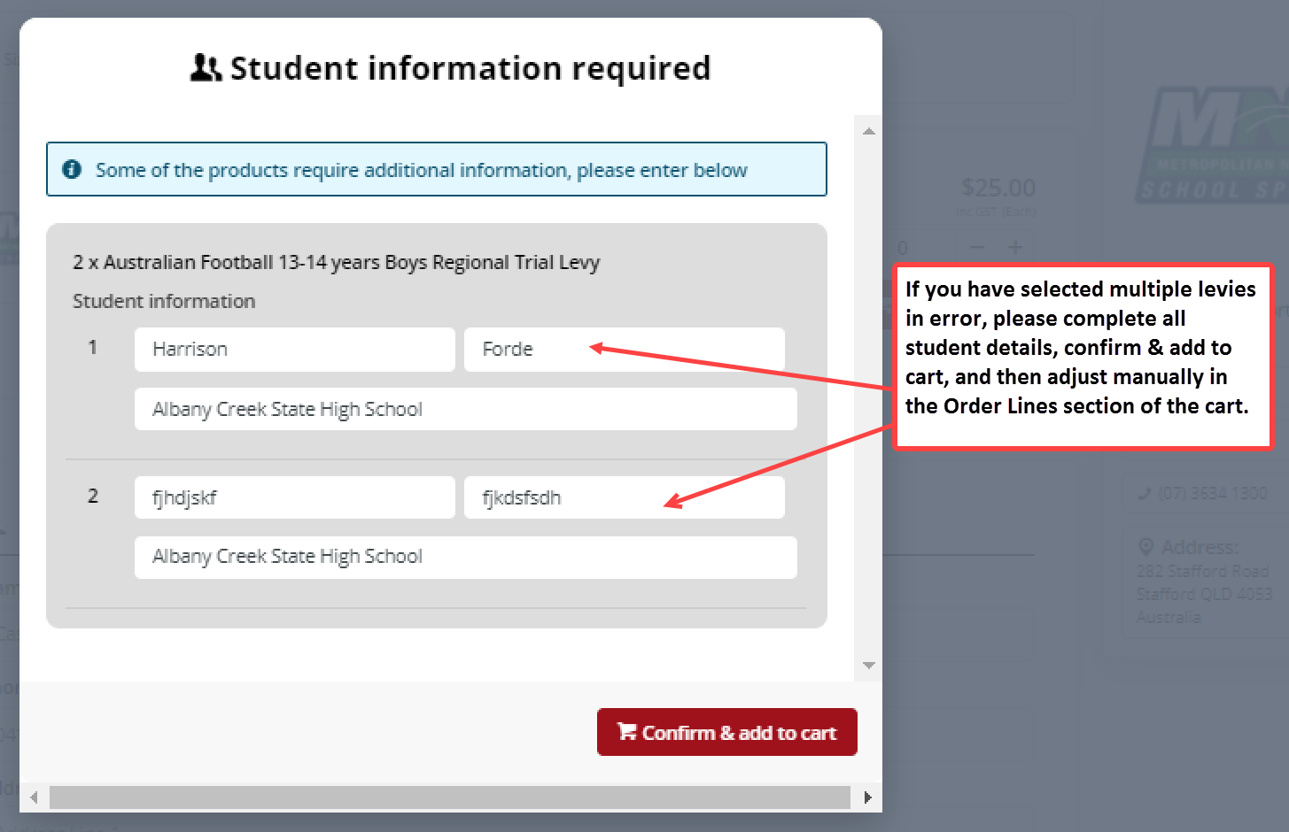  Any consecutive student entries can be dummy data (these are going to be removed).
 | Click the Confirm & add to cart button. | Click the Confirm & add to cart button to close the Student information pop up box.
 | Update the Levy Quantity. | Scroll down to the section called Order lines. This is where the levy and student information can be seen.  Adjust the quantity using the minus ‘-‘, button to the right of the levy quantity to decrease the number of levies, until the correct quantity appears.  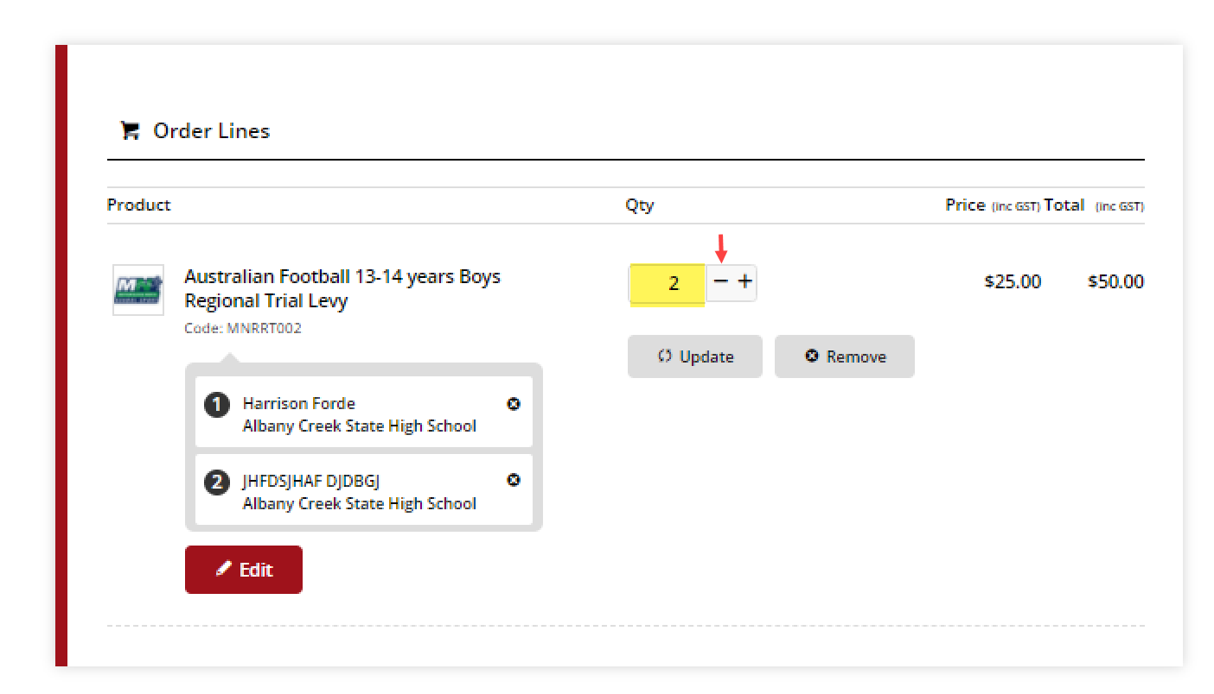
 | Click on the Update button. | 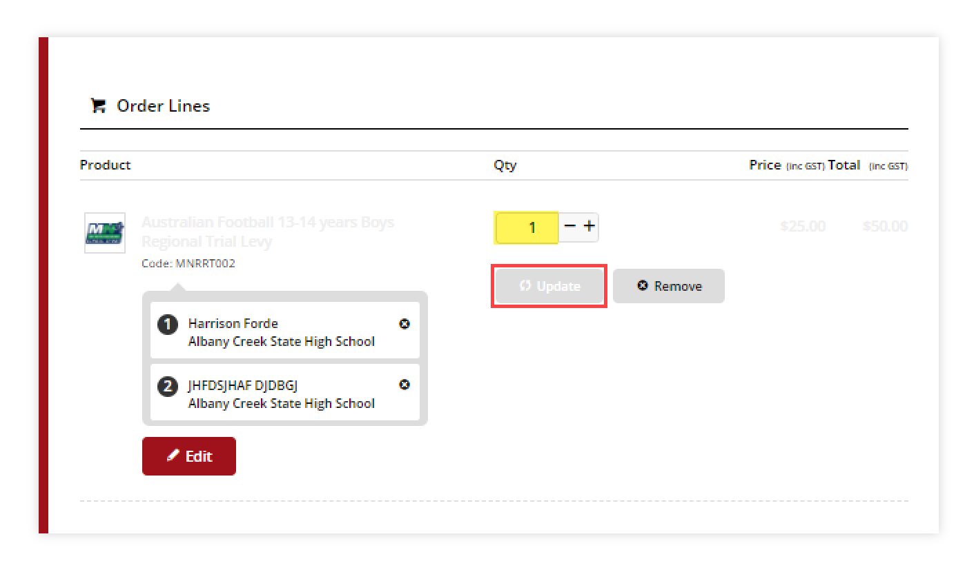  Click the Update button. The update button and other details of the levy appear to be greyed out on screen, but this is how the screen appears when it is in editor mode.
 | Click on the Update button. | Click the Update button again to apply the changes.  The screen will refresh and the Student Information Required pop up box will display again, but this time with only the first student.  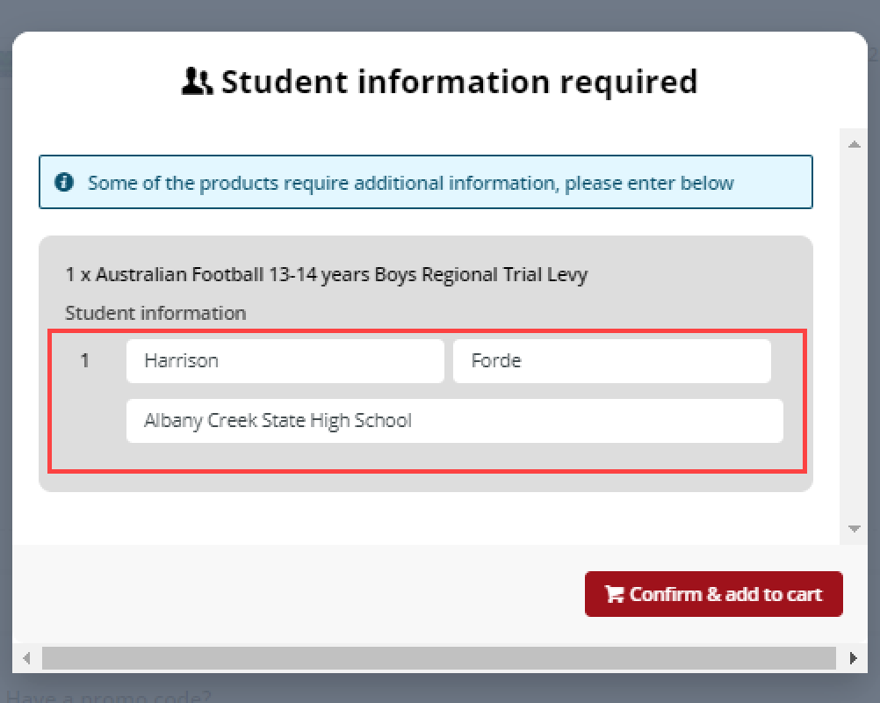
 | Click the Confirm & add to cart button. | Click the Confirm & add to cart button to close the Student information pop up box.
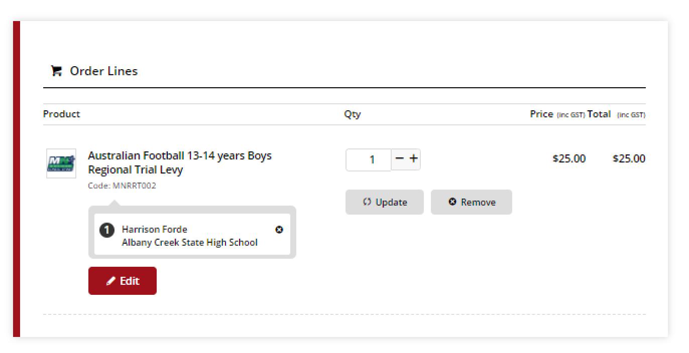
The Order Lines section has been updated and now appears with the correct number of levies, correct charges and correct student information. The Parent can now progress with the purchase.
Alternatively, clicking on the Remove button in the Order Lines section will clear the cart. The Parent can then start from the beginning; add the correct number of levies, add student details, then proceed with payment.
