Quick Reference Guide
Online shop returns and refunds
Parents and carers can request a return or refund via the online shop. The Regional School Sport (RRS) office will review the request and where appropriate, approve the return. If you have questions about your return, please contact your Regional School Sport office.
To request your refund:
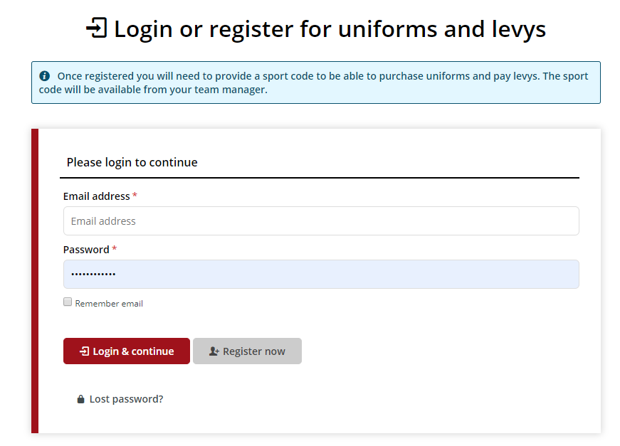
- Login to the online shop

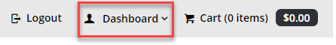
- Click on the dashboard icon to display options
- Click on order history
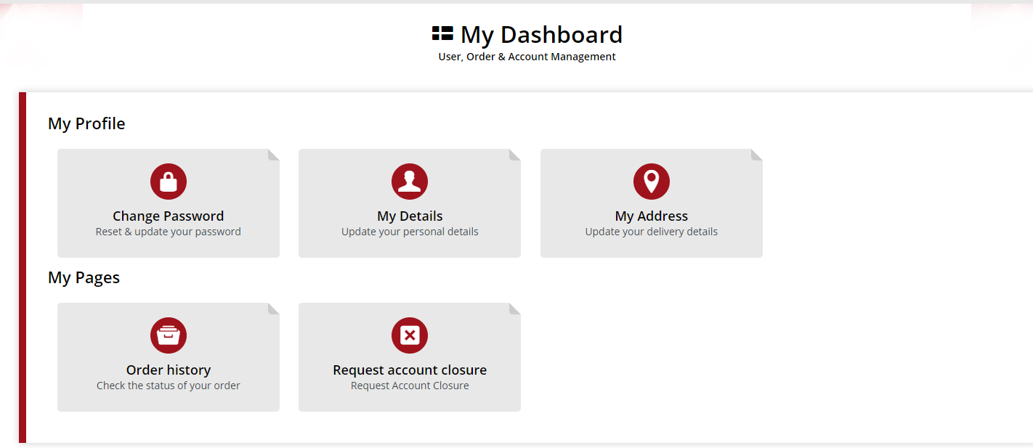
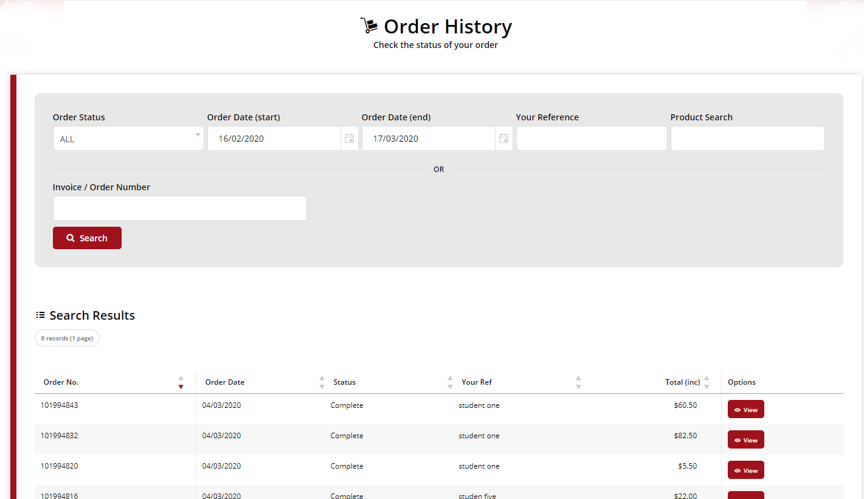

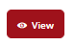
- Find the relevant order and click view

- When the order details appear
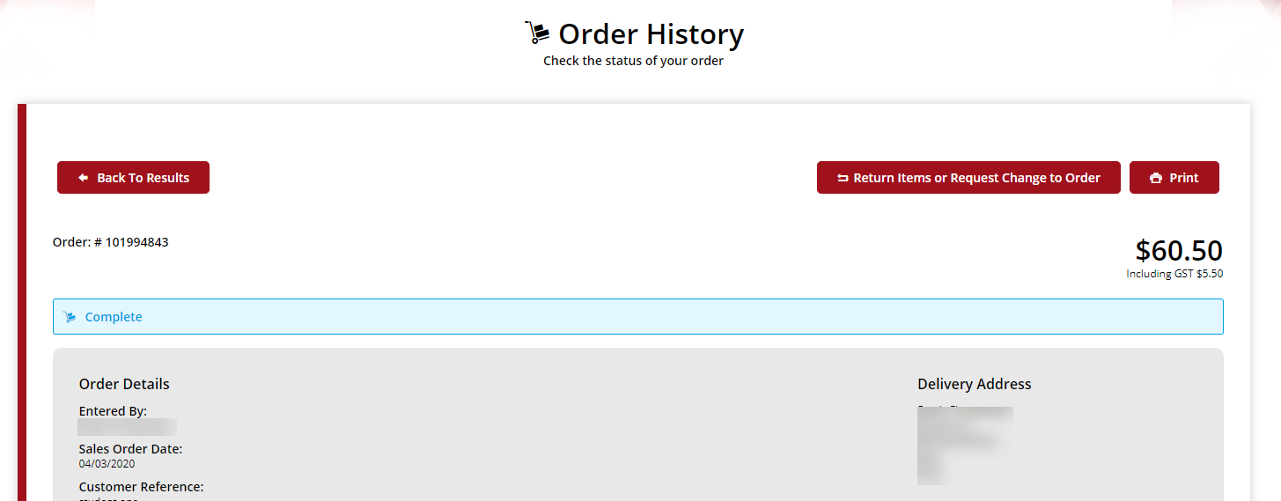

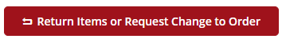
- Click on return items or request changes to order
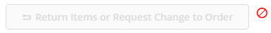
If the return items or request change to order button is greyed out, please refer to your RSS office quoting your order number.

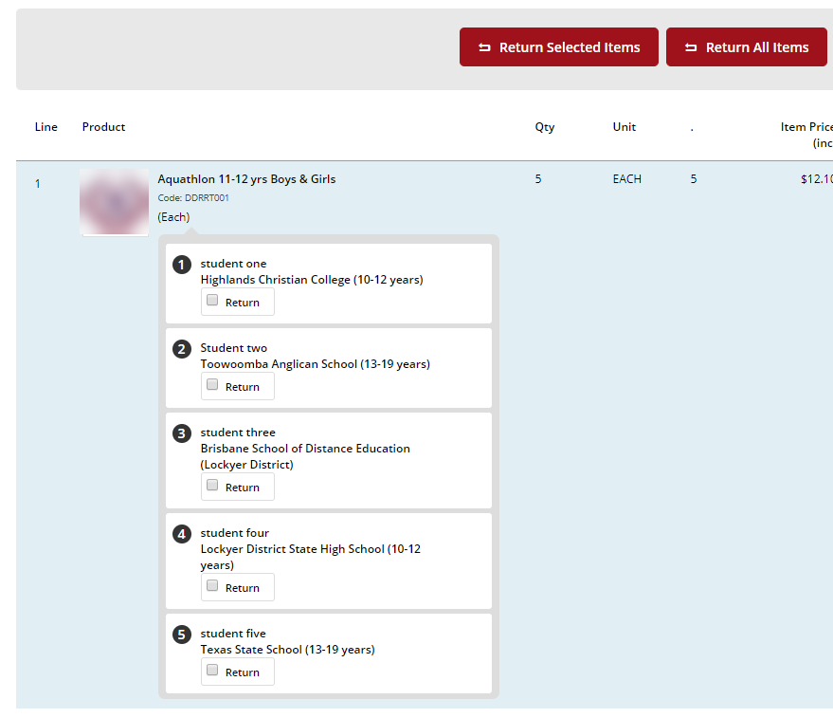
- The items available for return will be indicated

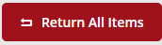
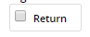
- Select the check box for the relevant item to be returned or click return all items
OR

- On the submit return screen, ensure all details are correct in the contact/billing address section.

- In return entry section, please select a reason code e.g. Item not required

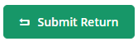
- Click submit return button

Once submitted, the return confirmation will be displayed. The parent or carer will also receive an email to confirm that the return request has been received.
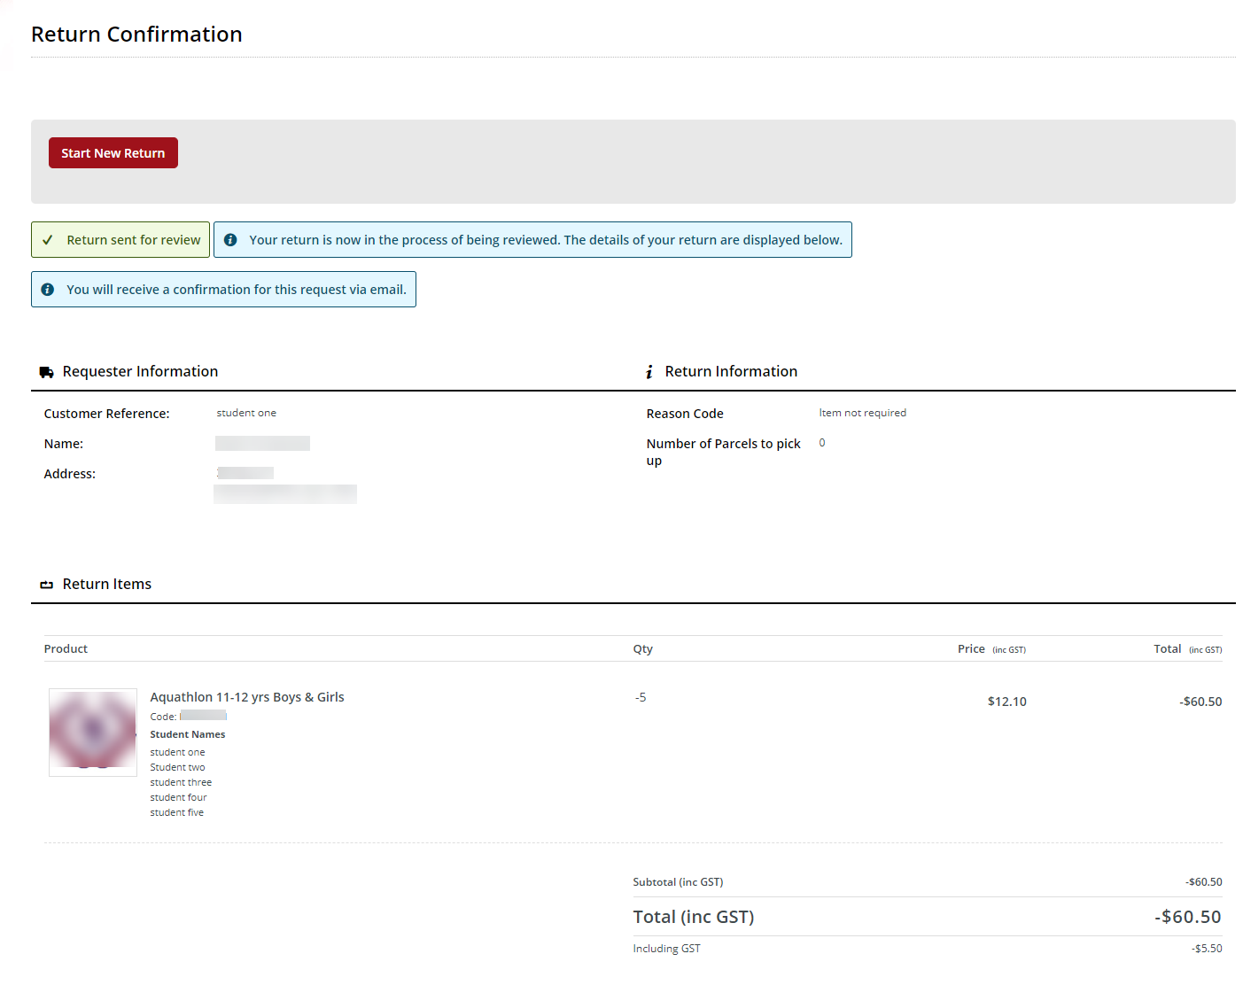

Help with the online shop
If you need help using the online shop, please contact the North West School Sport Office] via phone 07 4652 6607 or email nwsport@qed.qld.gov.au

