Representative School Sport online shop

How-to guide for parents

Getting started
Go to the North West School Sport website www.northwestschoolsport.eq.edu.au click on the Pay now Levies and apparel button to pay your levies.
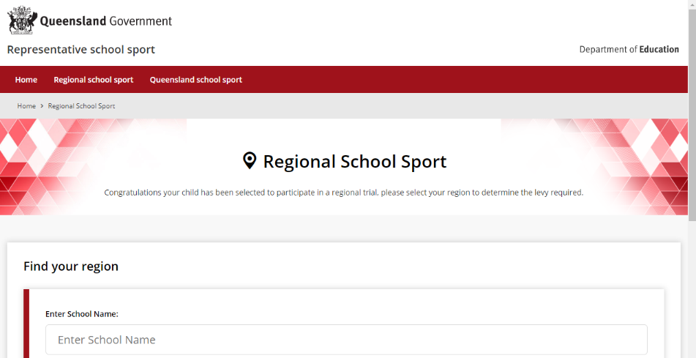
If you don’t know the region your child will be representing, go to RSSshop.education.qld.gov.au, click on regional school sport and search for your region using the name of your child’s school.

Regional trials
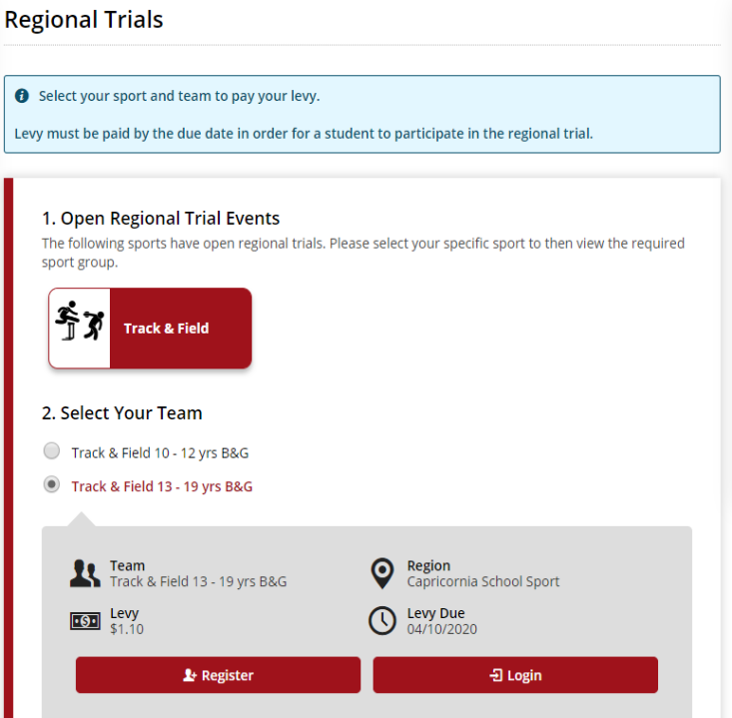
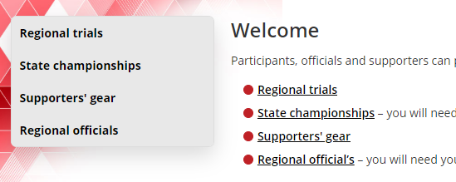
Once in the online shop, click on regional trials in the left navigation or the centre of your screen.
Select the sport and age group your child will participate in and click register if you are visiting for the first time or login if you have already registered.
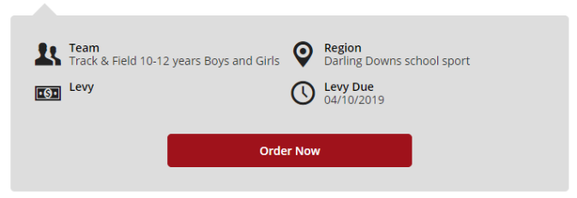
If you are already logged in, the confirmation section will show the option to order now.

To register
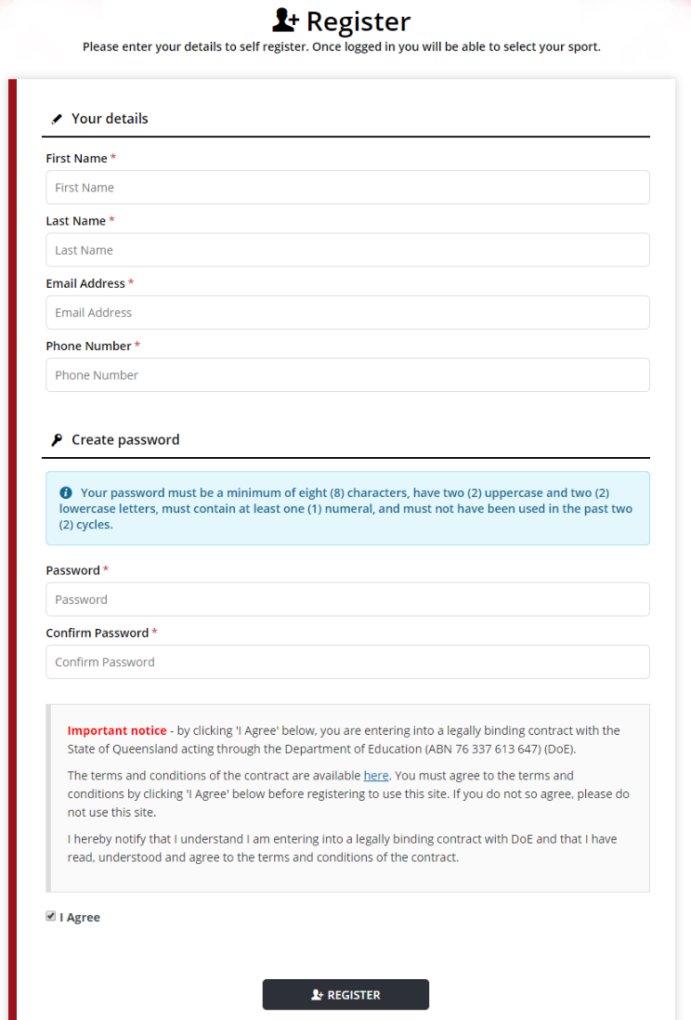
Complete your contact details, create a password, read and agree to the terms and conditions of the online shop and click register.

Login
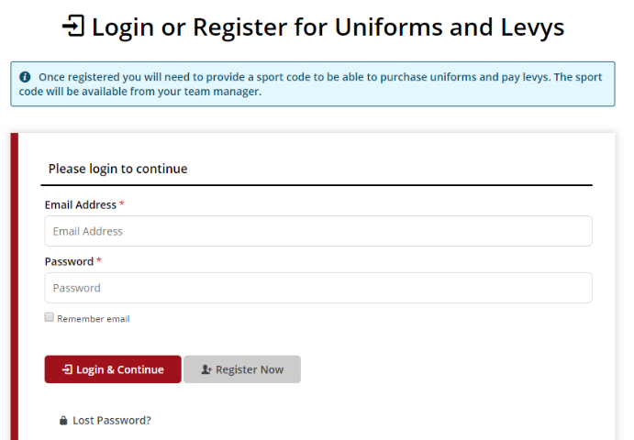
If you have already registered, enter your email address and password and click login & continue.

Placing your order
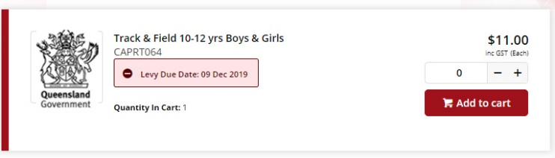
Once you have logged in, select the quantity and click add to cart. You will be asked to enter your child’s student information including name and school.

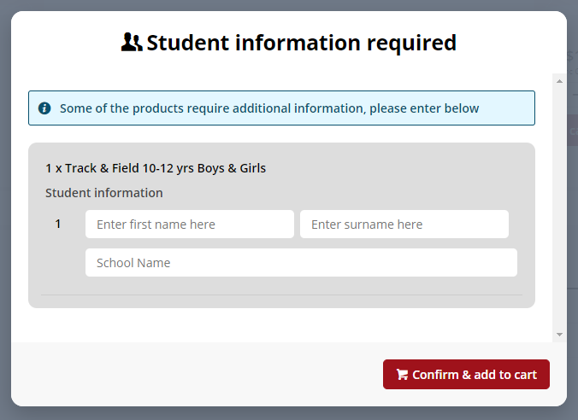
On the order confirmation page, complete your contact / billing address, ensure the student details in order information and the sport and age group in order lines is correct.

Payment information
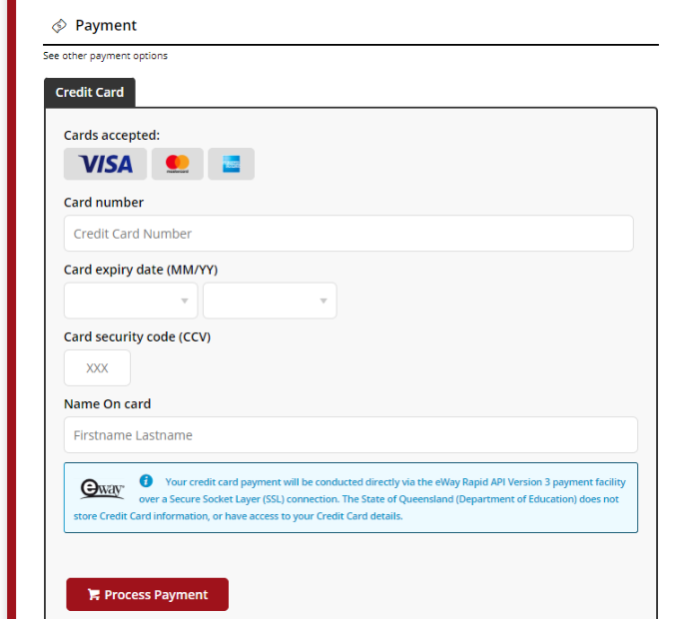
Enter your credit card details and click process payment.

Order confirmation
Once your payment is accepted, your order confirmation will be shown on screen and emailed to you immediately.

Help with the online shop
If you need help using the online shop:
Please click on the Frequently asked questions link at the bottom of the website page, 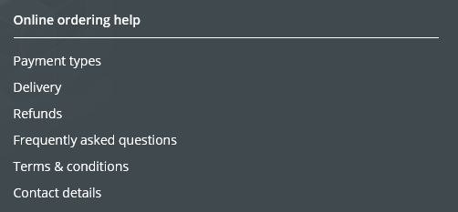
OR
Please contact your child’s school for assistance
Or
Please contact the North West School Sport Office via phone 07 4652 6607 or email linda.ashburn@qed.qld.gov.au

