Representative School Sport online shop

How-to guide for parents

State championships
If your child has been successful at regional trials and selected to compete in state championships, you will need to pay any levies for participation and purchase compulsory uniform items. There may be additional uniform items available to purchase.

Getting started

Go to the North West School Sport website www.northwestschoolsport.eq.edu.au and click on the Pay now Levies and apparel button to pay your levies and purchase apparel.

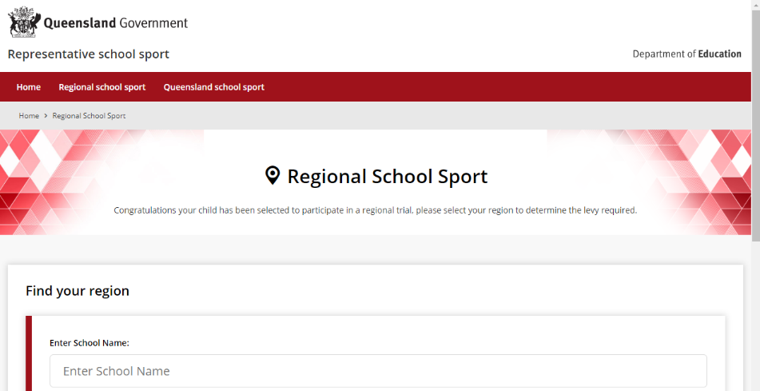
If you don’t know the region your child will be representing, go to RSSshop.education.qld.gov.au, click on regional school sport and search for your region using the name of your child’s school.

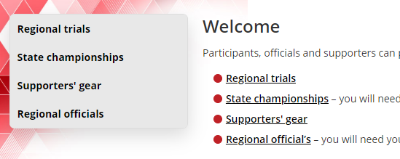
Click on state championships in the left navigation or the centre of your screen

If this is your first time visiting the online shop, click register or if you are a returning visitor, click login.

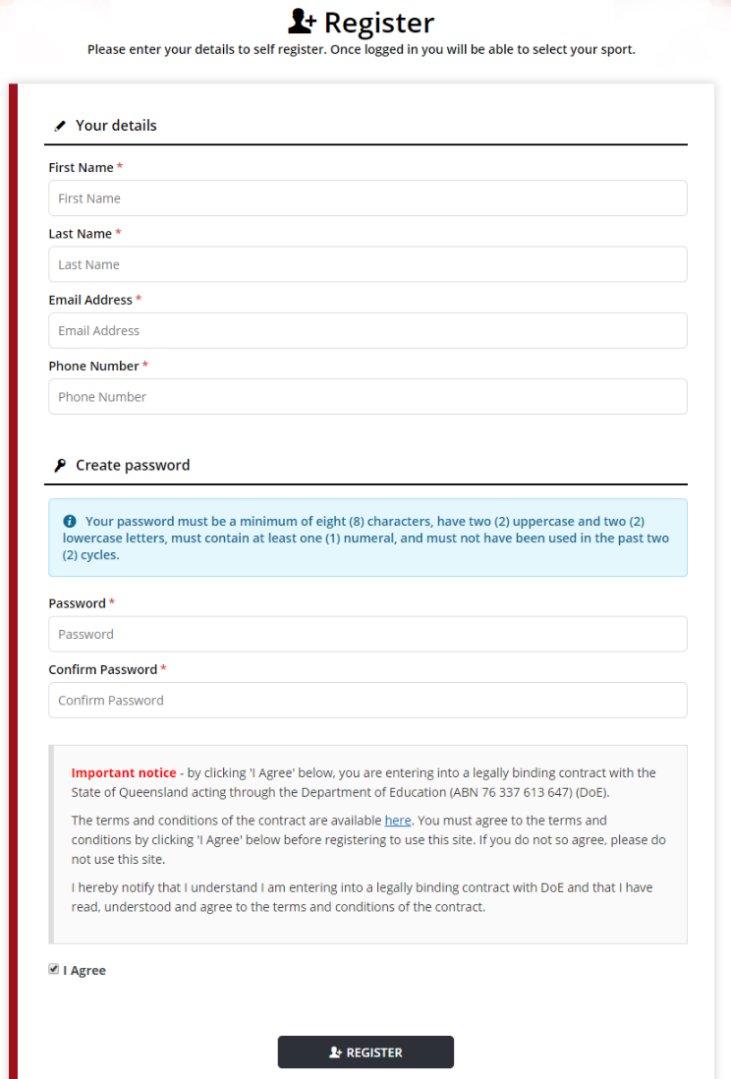
To register
If you are visiting the online shop for the first time, click register. Complete your contact details, create a password, read and agree to the terms and conditions of the online shop and click register.

Login
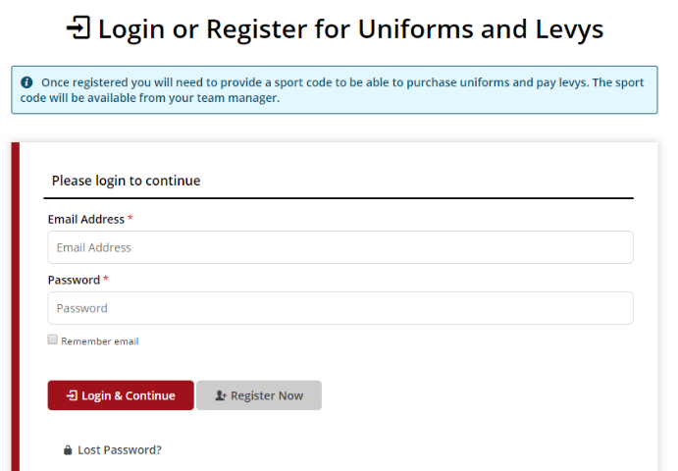
If you have already registered, enter your email address and password and click login & continue.

Once you have logged in, enter the sports code provided by your regional school sport office.

If you have not received your sports code, please contact the regional school sport office.

Placing your order
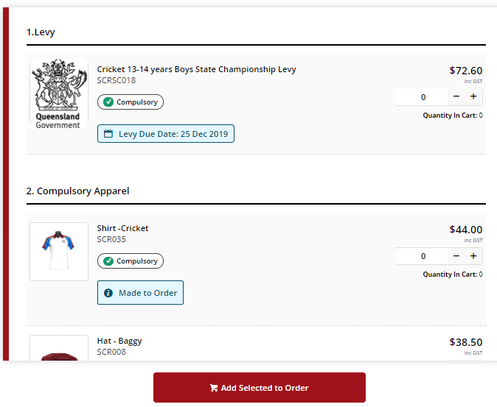
You will be redirected to the product catalogue to place your order. The product catalogue outlines any levies payable along with compulsory and optional uniform items.
Select the levy, compulsory uniform items and any optional items you wish to purchase and click add selected to order.

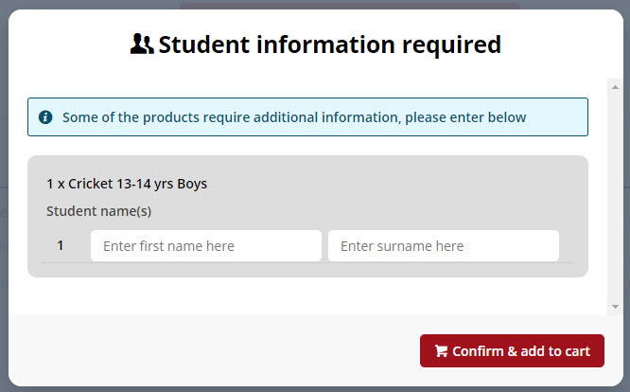
You will then be asked to add your child’s details in student information. Enter their name and click confirm & add to cart. You will then be returned to the product catalogue.
Select your preferred delivery method based on the options available for your region, complete your contact / billing address, ensure the student details in order information and the sport, age group and uniform items in order lines is correct.
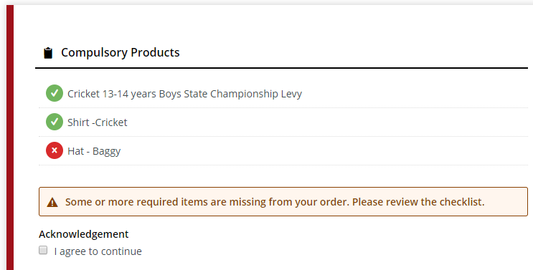
If there are compulsory uniform items that have not been added to your cart, for example if your child already owns the compulsory hat, a warning will appear on screen. Simply click the agree button to acknowledge you do not need to purchase these items and continue.

Payment information
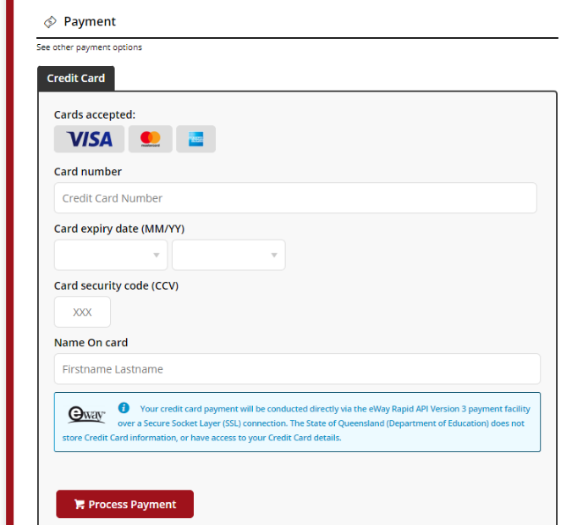
Enter your credit card details and click process payment.

Order confirmation
Once your payment is accepted, your order confirmation will be shown on screen and emailed to you immediately.

Help with the online shop
If you need help using the online shop:
Please click on the Frequently asked questions link at the bottom of the website page, 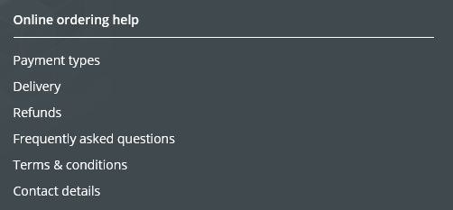
OR
Please contact your child’s school for assistance
Or
Please contact the North West School Sport Office via phone 07 4652 6607 or email linda.ashburn@qed.qld.gov.au

